December 10, 2024

Developer - RPA

RED SKY HEALTH

Claim Status BOT

Elevated health

Elevated health

Contents

Project Details 2

Project Overview 2

Input 2

Execution Steps 3

Output 6

# Project Details

|  |  |
| --- | --- |
| Project Type | Claim Status |
| Client Name | Rume Medical Group, Elevated Health |
| Project Manager | Sanjith Nair |
| Developer | Arun Kumar |
| Developed Platform | UiPath |
| Kick-Off Date | 09/16/2024 |
| Live Date | 09/19/2024 |

# Project Overview

A robust UiPath Robotic Process Automation (RPA) solution to automate the repetitive and time-consuming task of checking claim statuses within CollaborateMD. This automation streamlines the revenue cycle management process, reducing manual effort and improving operational efficiency.

**Objectives**

* Automate claim status verification for multiple insurance providers
* Minimize manual data entry and reduce human error
* Accelerate revenue cycle management processes
* Provide real-time tracking and reporting of claim statuses

**Key Features**

* Automated login to practice management suite
* Dynamic claim status retrieval across multiple insurance carriers
* Error handling and logging mechanisms
* Export of claim status results to a designated spreadsheet

# Input

Input data is needed in the spreadsheet format embedded below.



# Execution Steps

**Step 01:** Open to UiPath Studio

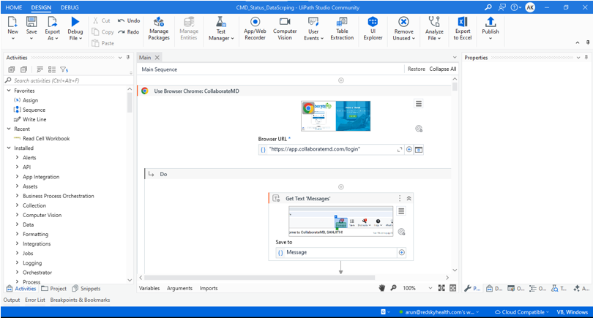

**Step 02:** Click to Run



**Step 03:** login to website

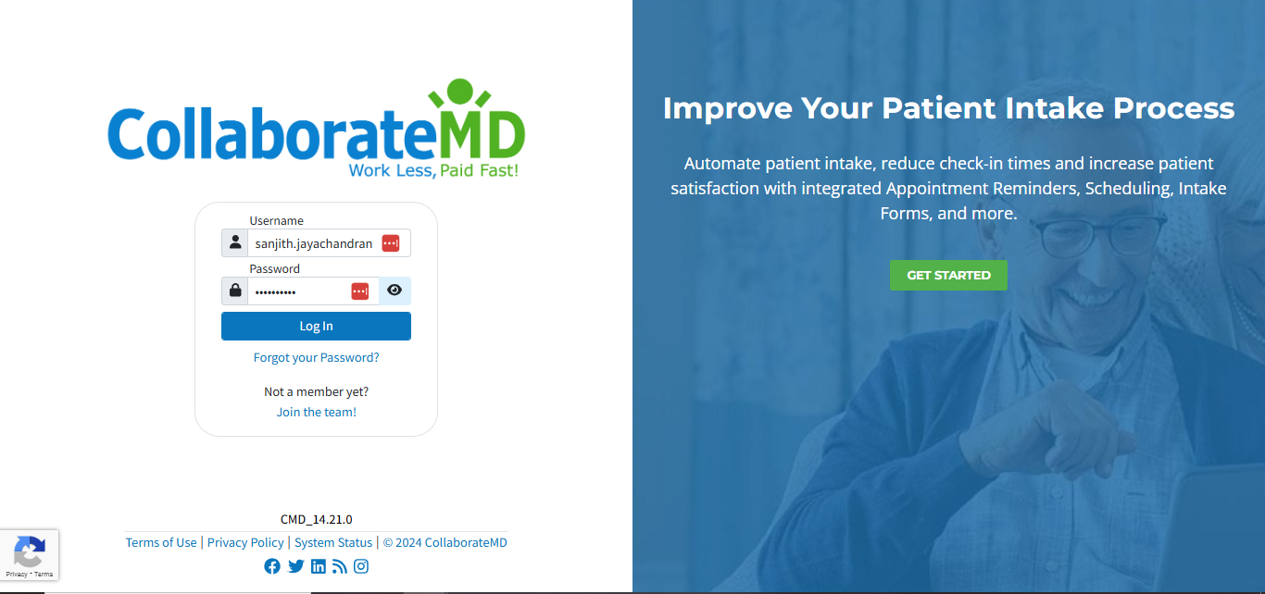

**Step 04:** Click to claim  
  
  
  
 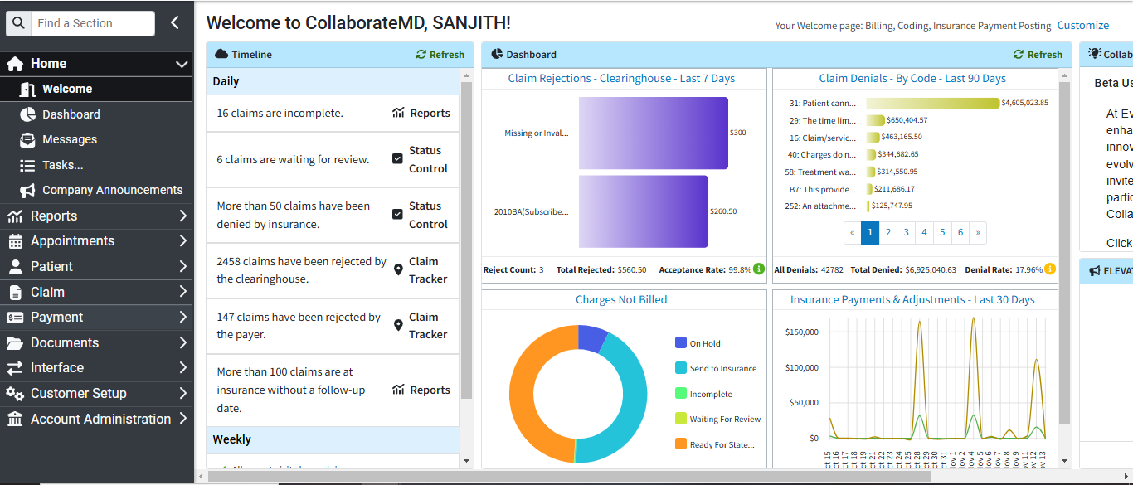

**Step 05:** Search to Claim ID 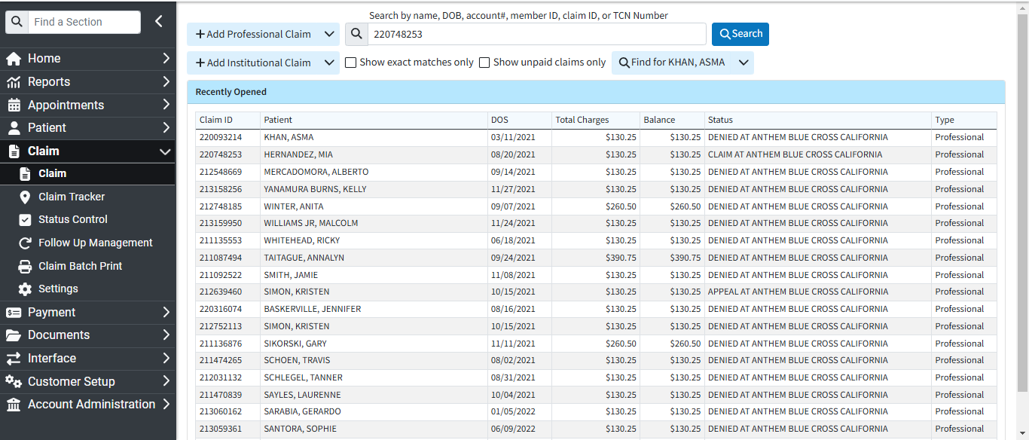

**Step 06:** Click to Claim Status 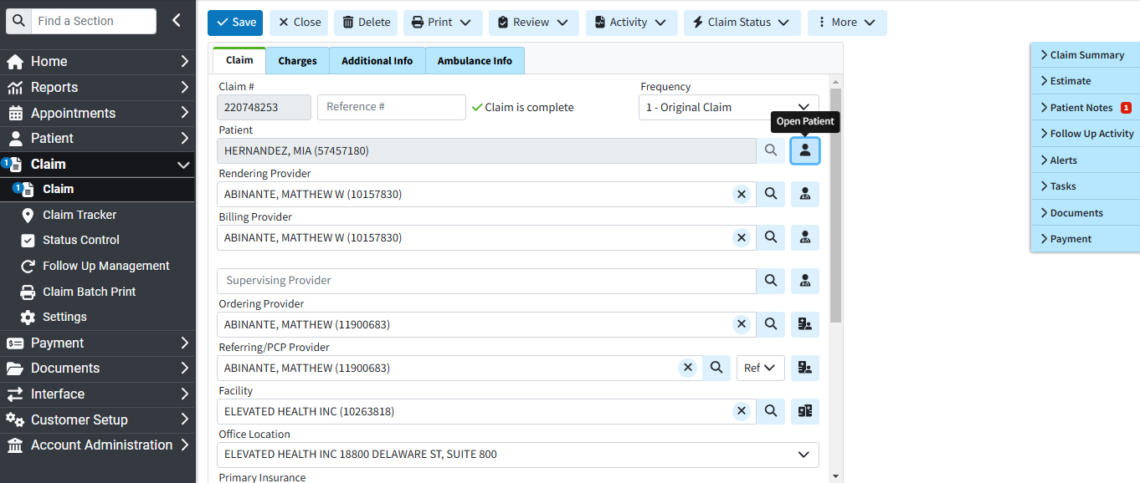

**Step 07:** scraper to input the text for the CPT Level.

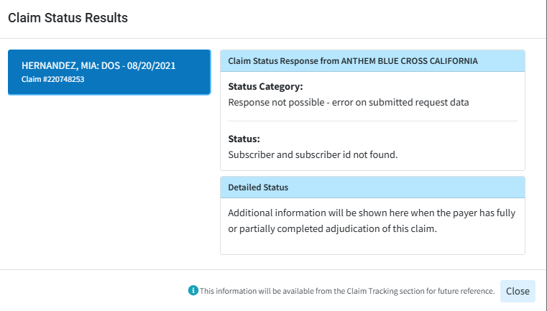

# Output

The output would be saved in the bot's same location path.